E-Commerce Application Deployment on AWS EKS | End-to-End DevSecOps Project
Proud to share one of my end-to-end DevSecOps projects where I designed, implemented, and deployed a production-ready E-Commerce application using modern cloud-native tools.
Tech Stack & Tools
- Cloud: AWS (EC2, IAM, EKS, VPC, Security Groups)
- CI/CD: Jenkins (Pipeline as Code)
- Containerization: Docker
- Orchestration: Kubernetes (EKS)
- Code Quality: SonarQube
- Artifact Management: Nexus Repository
- Security: Trivy (Filesystem & Image Scanning)
- Build Tool: Maven
- Monitoring/Notifications: Email Alerts via Jenkins
Project Highlights
- Created Jenkins, SonarQube, and Nexus on dedicated EC2 instances
- Built a secure EKS cluster using eksctl with managed node groups
- Implemented IAM best practices (IAM user, policies, OIDC, RBAC)
- Designed CI/CD pipeline with:
  - Git checkout
  - Maven build & test
  - SonarQube code analysis
  - Trivy security scanning
  - Artifact publishing to Nexus
  - Docker image build, scan & push
  - Automated deployment to EKS
- Used Kubernetes RBAC & Service Accounts for secure cluster access
- Deployed application via Kubernetes Deployment & Service
- Enabled email notifications for pipeline success/failure
📦 Outcome
- Fully automated CI/CD + CD pipeline
- Secure, scalable containerized deployment on AWS EKS
- Production-ready DevSecOps workflow following industry best practices
This project helped me strengthen my hands-on experience with AWS, Kubernetes, Jenkins, and DevSecOps pipelines.
AWS EC2 Infrastructure (Jenkins / Monitoring Servers)
Provisioned and managed multiple AWS EC2 instances hosting Jenkins, ingress, microservices nodes, and Prometheus–Grafana monitoring server, all secured using common security groups and best practices.
Key Skills Highlighted:
AWS EC2 • Security Groups • Linux • Monitoring Setup • Production Infrastructure
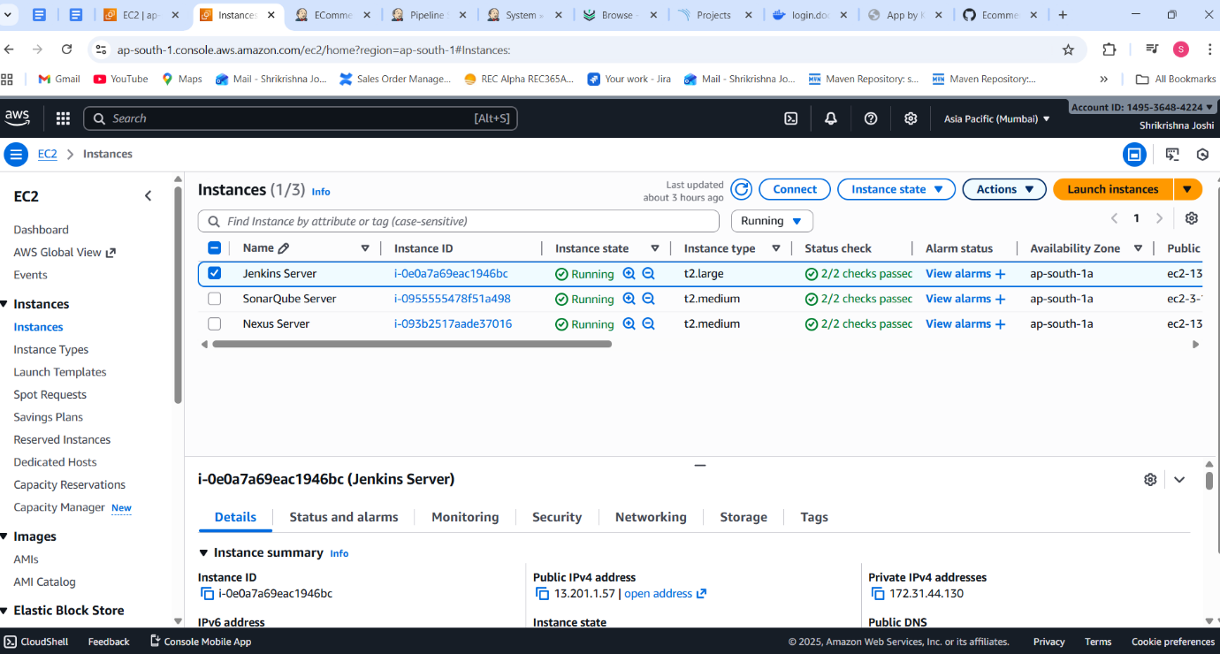
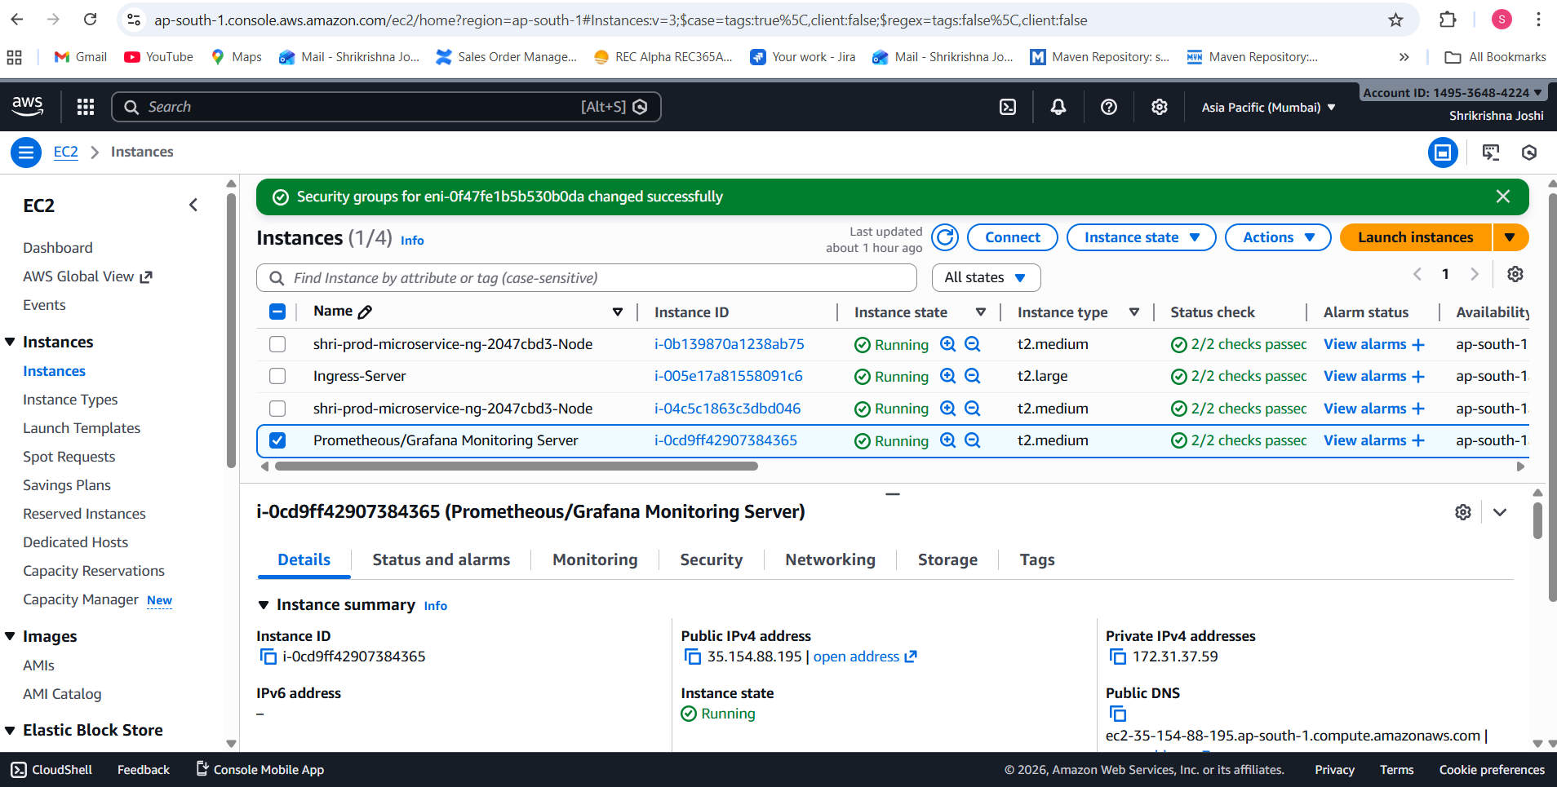
Nexus Repository – Artifact Management
Artifacts published to Sonatype Nexus (maven-snapshots & releases), enabling version-controlled builds and promoting stable artifacts across environments.
Highlights:
Nexus Repository • Maven Artifacts • Versioning • Release Management
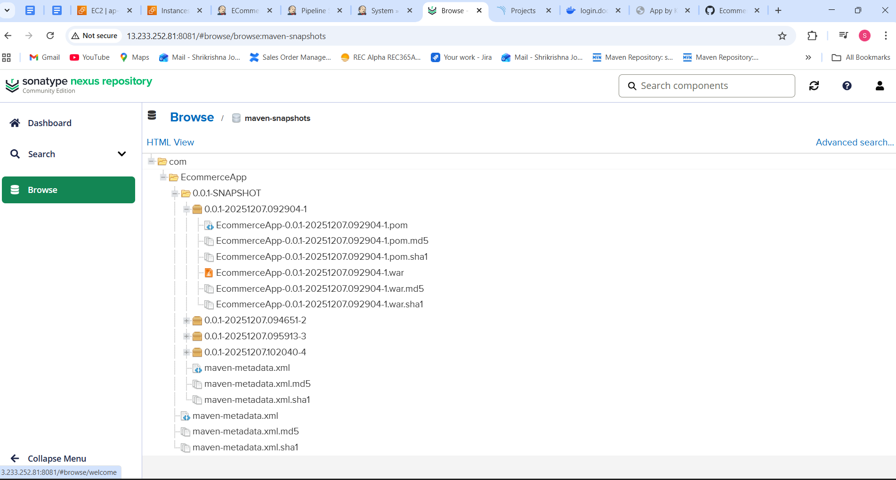
SonarQube – Code Quality & Security
Static code analysis using SonarQube to identify bugs, vulnerabilities, code smells, and enforce quality gates before deployment.
Highlights:
SonarQube • Code Quality • Security Analysis • Quality Gates

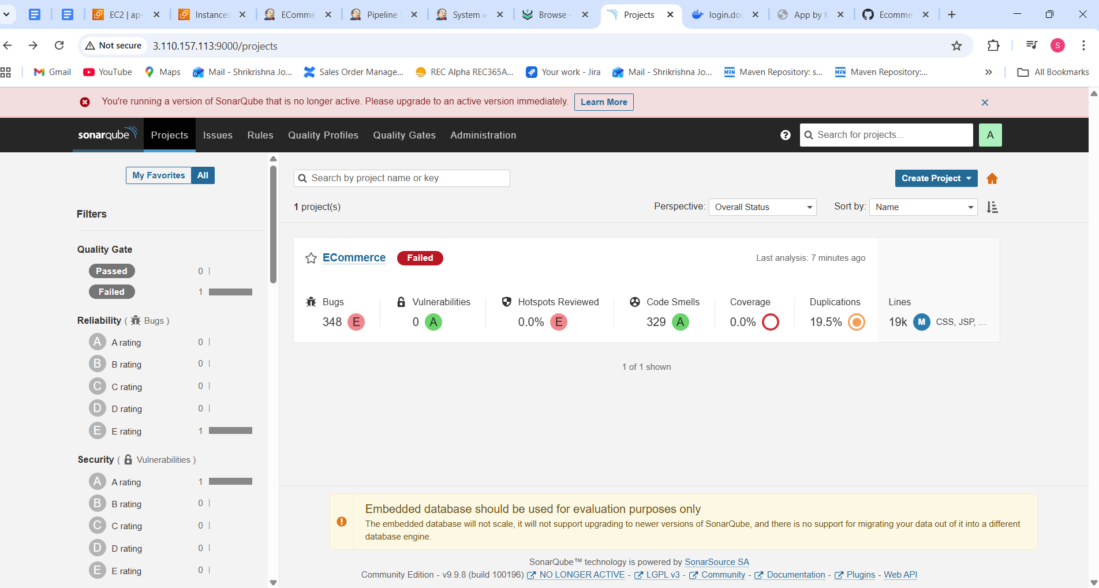
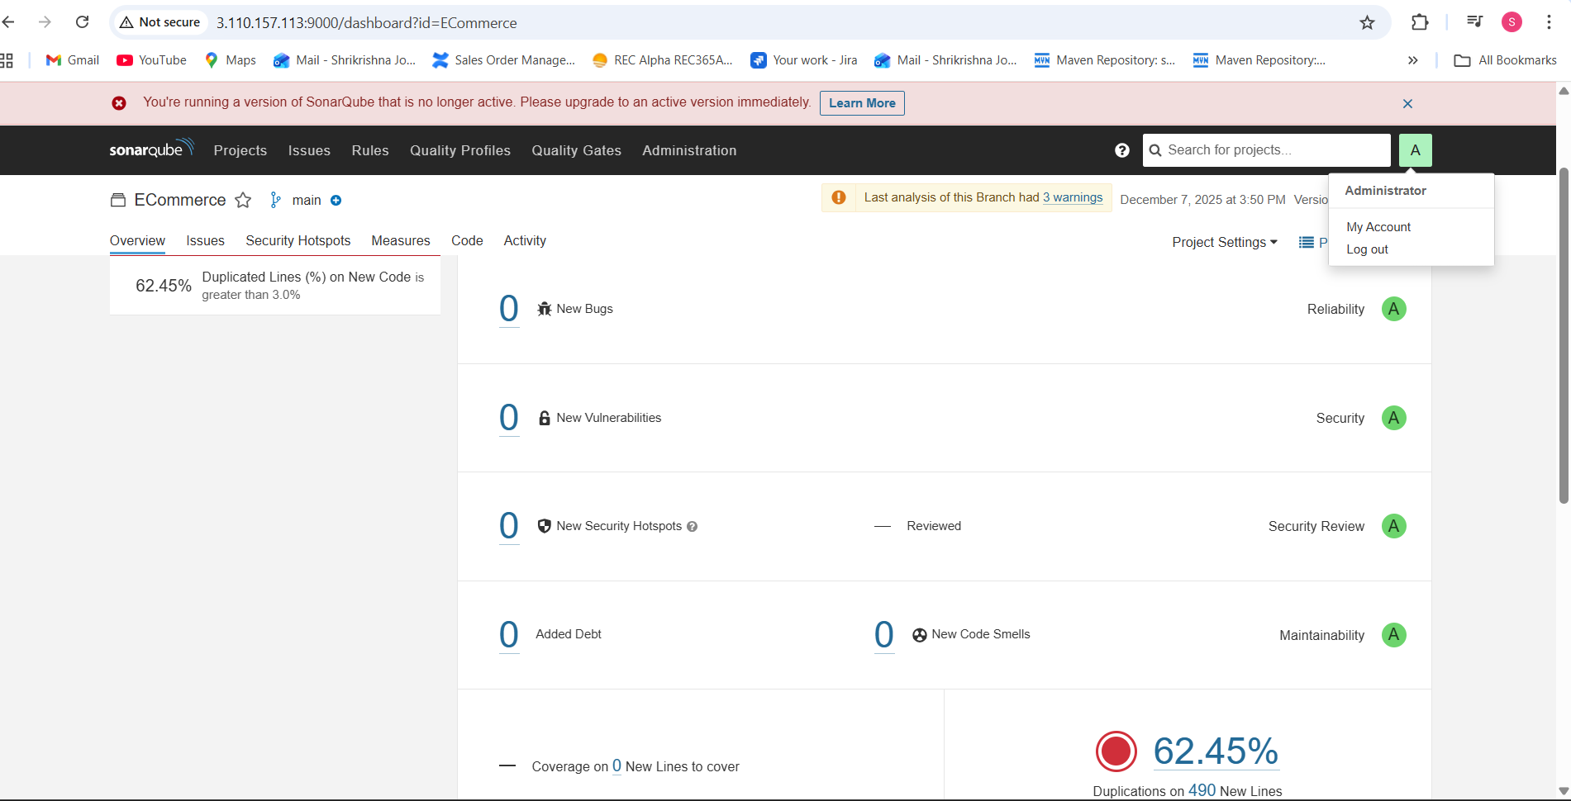
Jenkins CI/CD Pipeline – Stage View
End-to-end Jenkins Declarative Pipeline automating Git checkout, Maven build & test, SonarQube analysis, Trivy security scans, Nexus artifact publishing, Docker image build, push, and deployment.
Highlights:
CI/CD • Jenkins Pipelines • Maven • Docker • DevSecOps Automation
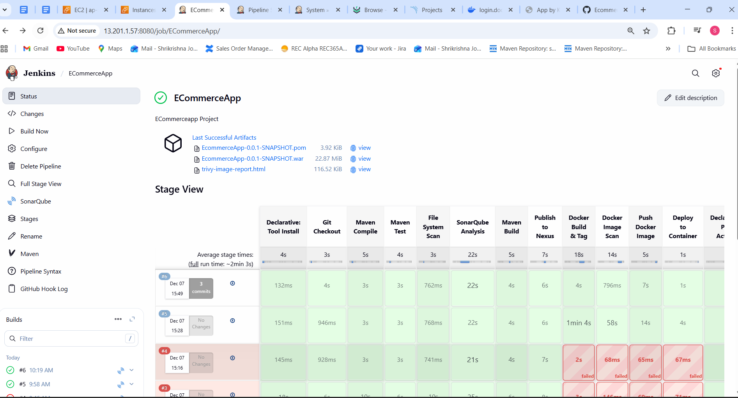
DockerHub Repository (Container Image)
Built, tagged, scanned, and pushed the E-Commerce application Docker image to DockerHub using Jenkins CI/CD pipeline for consistent and repeatable deployments.
Key Skills Highlighted:
Docker • CI/CD • Image Versioning • DockerHub • Automation
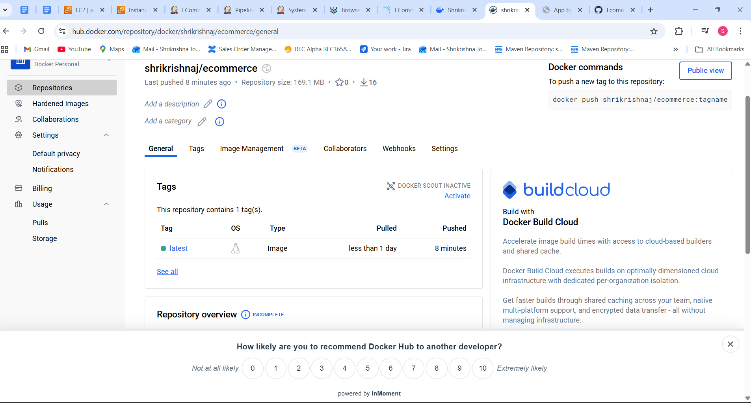
Live E-Commerce Application (Deployed)
Successfully deployed and accessed the E-Commerce web application running inside a containerized environment, exposed via service endpoint and verified through browser access.
Key Skills Highlighted:
Application Deployment • Container Runtime • Web App Validation • End-to-End Delivery
